Relationship between machine learning, linear algebra and vectors and matrices.

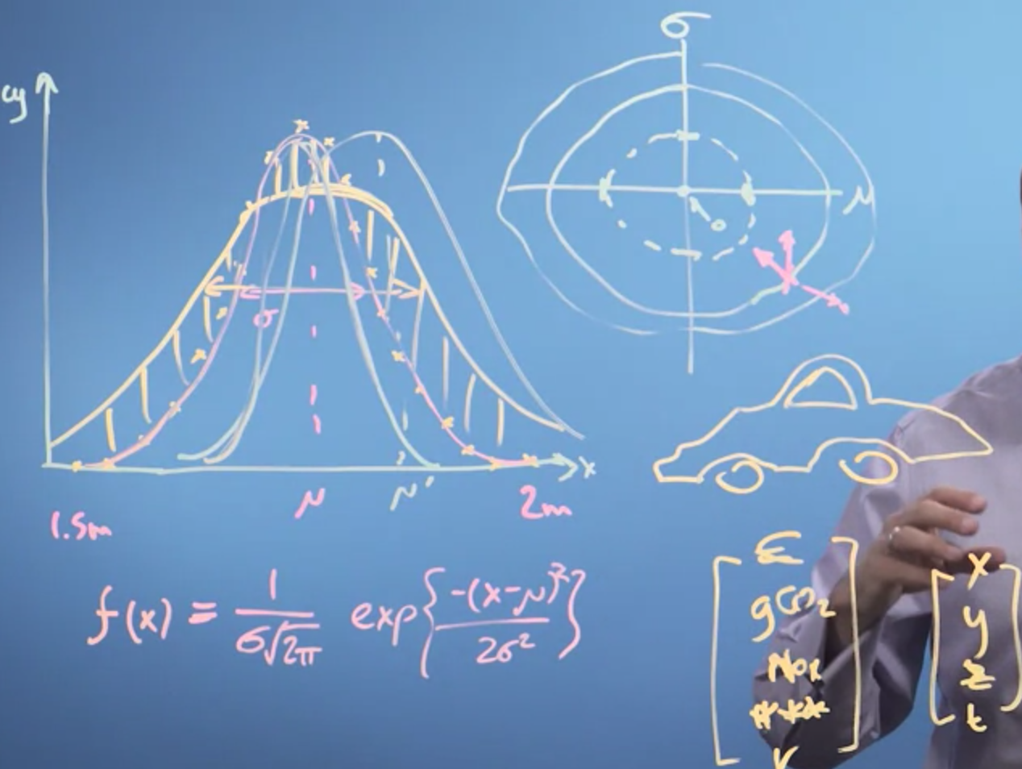

So, in this video, we've revisited the problem of fitting a function to some data, in this case, the distribution of heights in the population.

What we've seen is the function we fit, whatever it is, has some parameters. And we can plot how the quality of the fit, the goodness of the fit, varies as we vary those parameters. Moves around these fitting parameter space are then just vectors in that space of fitting parameters. And, therefore, we want to look at and revisit vector maths in order to be able to build on that, and then do calculus, and then do machine learning.

House – Vector , that describes that object.

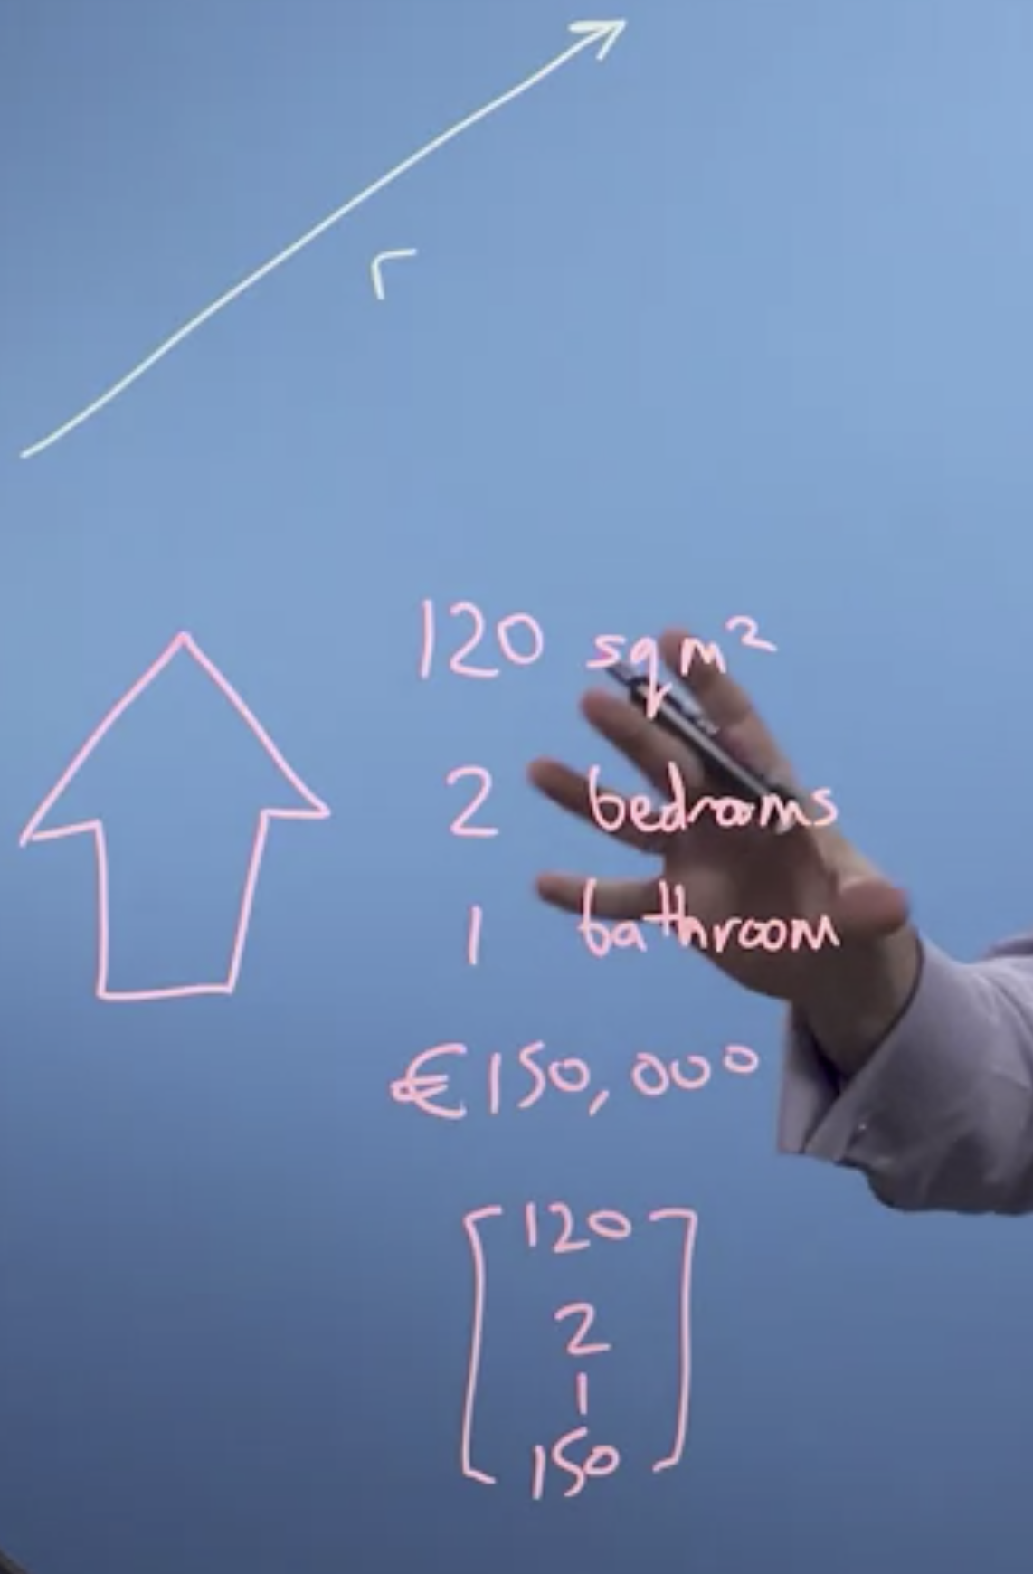

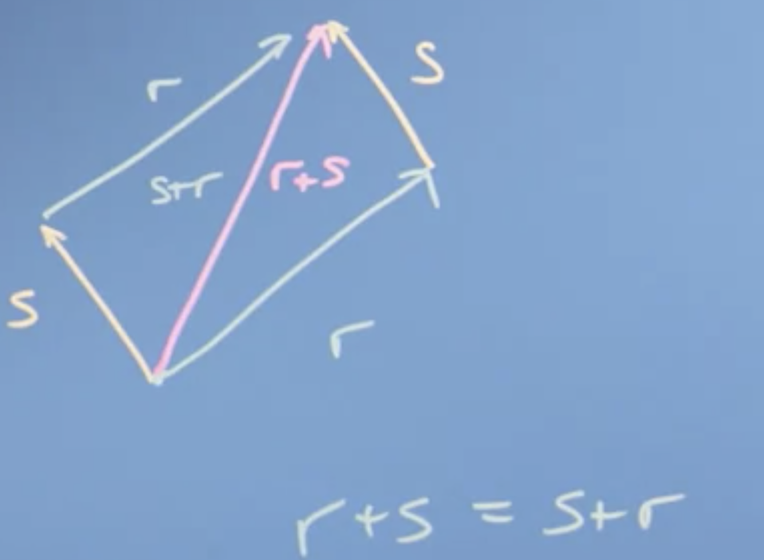

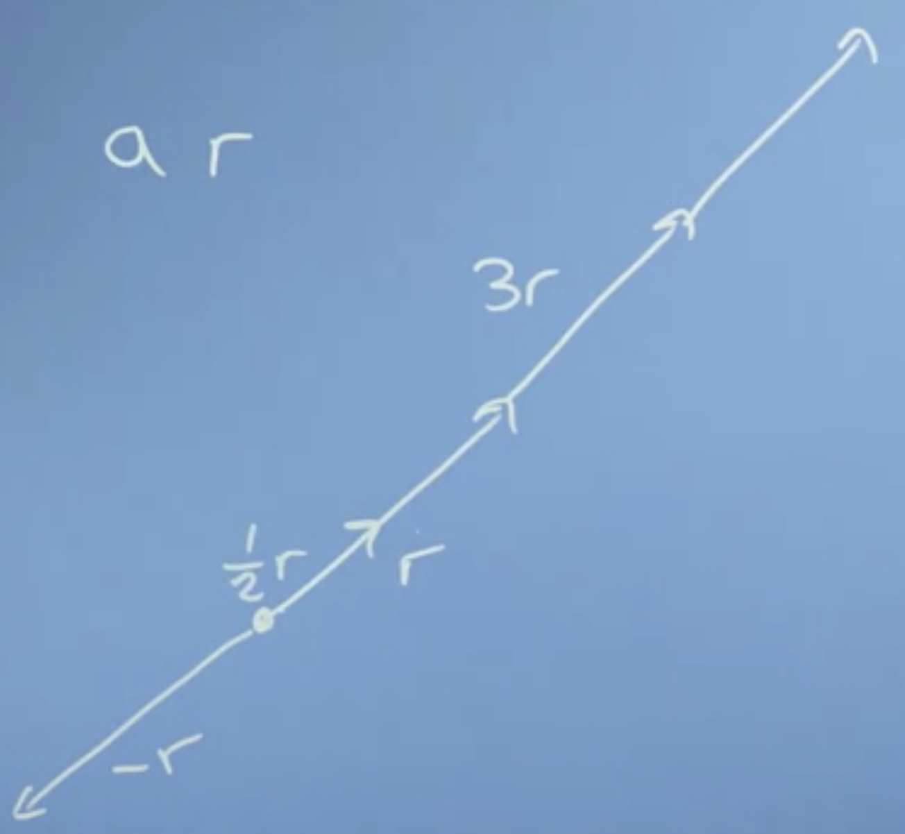

Unit vectors to describe the space. I , j . Vector addition is associative.

Vector operations: Addition and scalar multiplication.

Size and dot product of the vector:

Dot product also called it’s inner scalar or projection product.

Size of the vector is the sums of the square of the components and taking a square root.

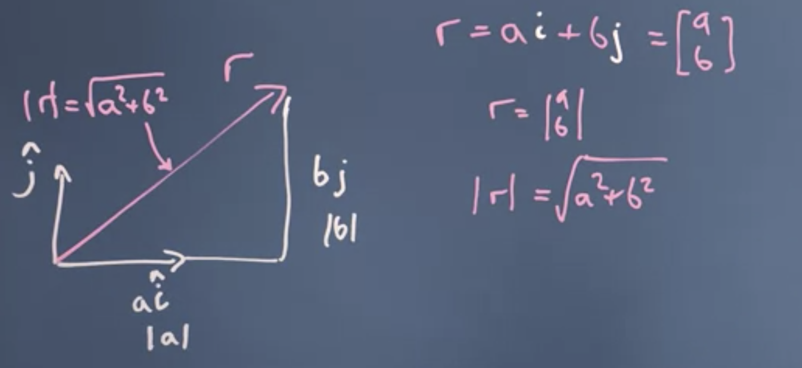

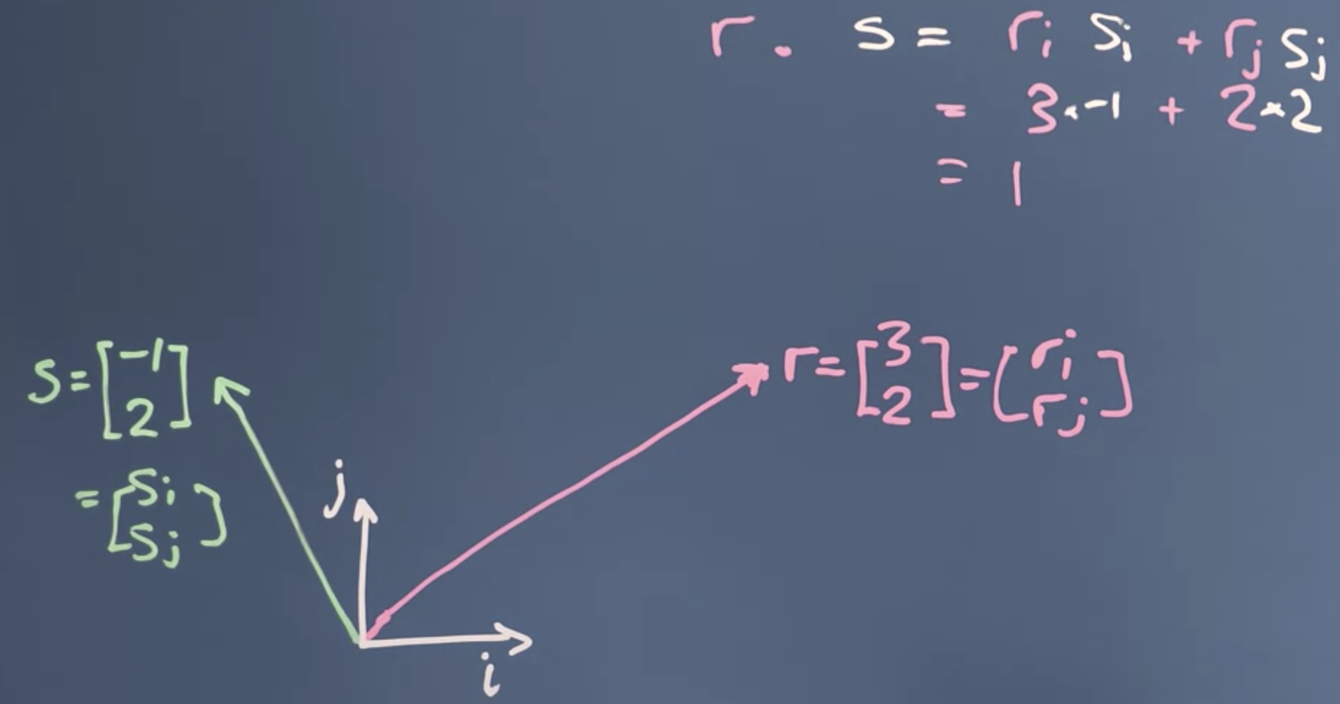

Commutative: dot product.

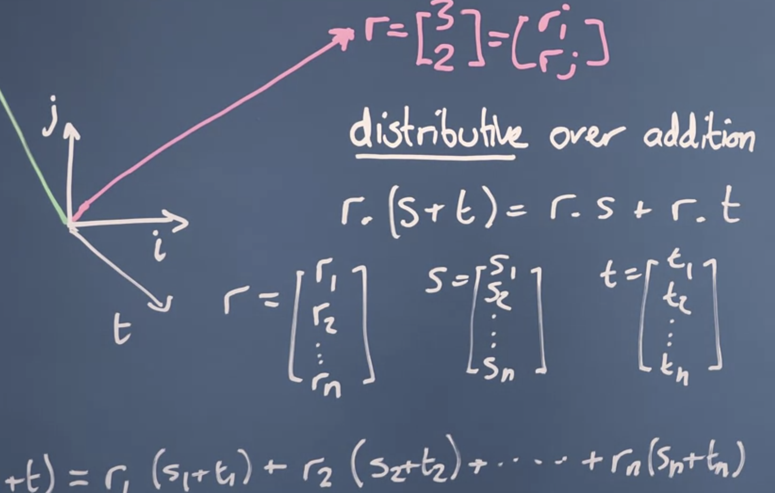

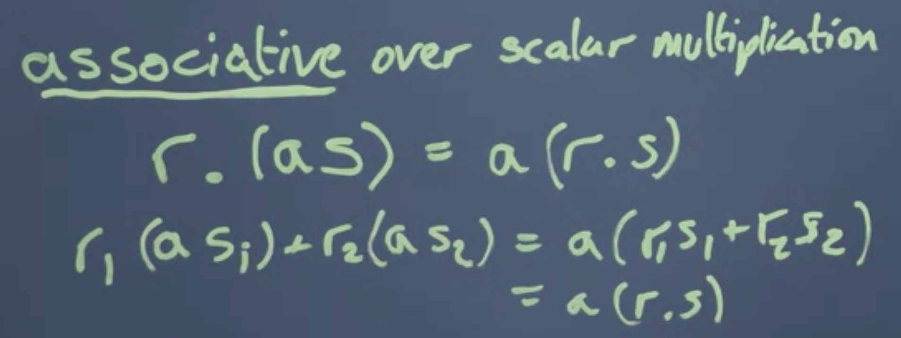

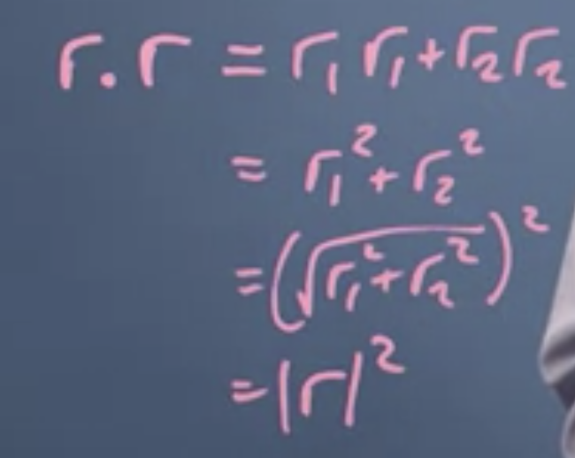

Take the dot product of a vector to itself and then take the square root of it to get the magnitude of the size.

Cosine and Dot Product.

Using the cosine rule, we can find the direction of two vectors with respect to each other.

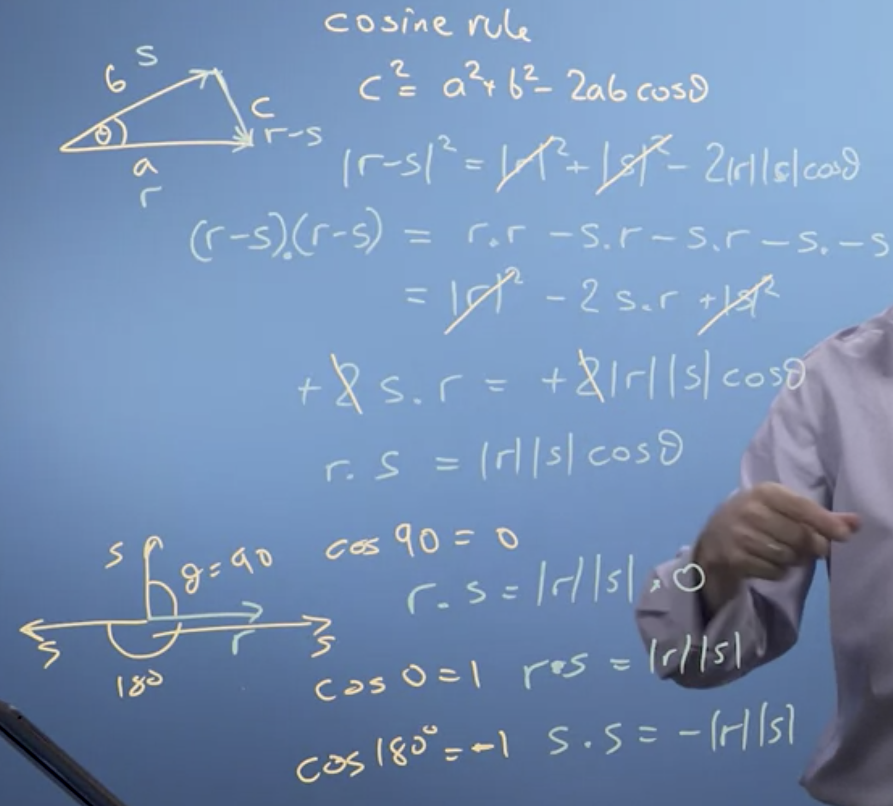

Projection:

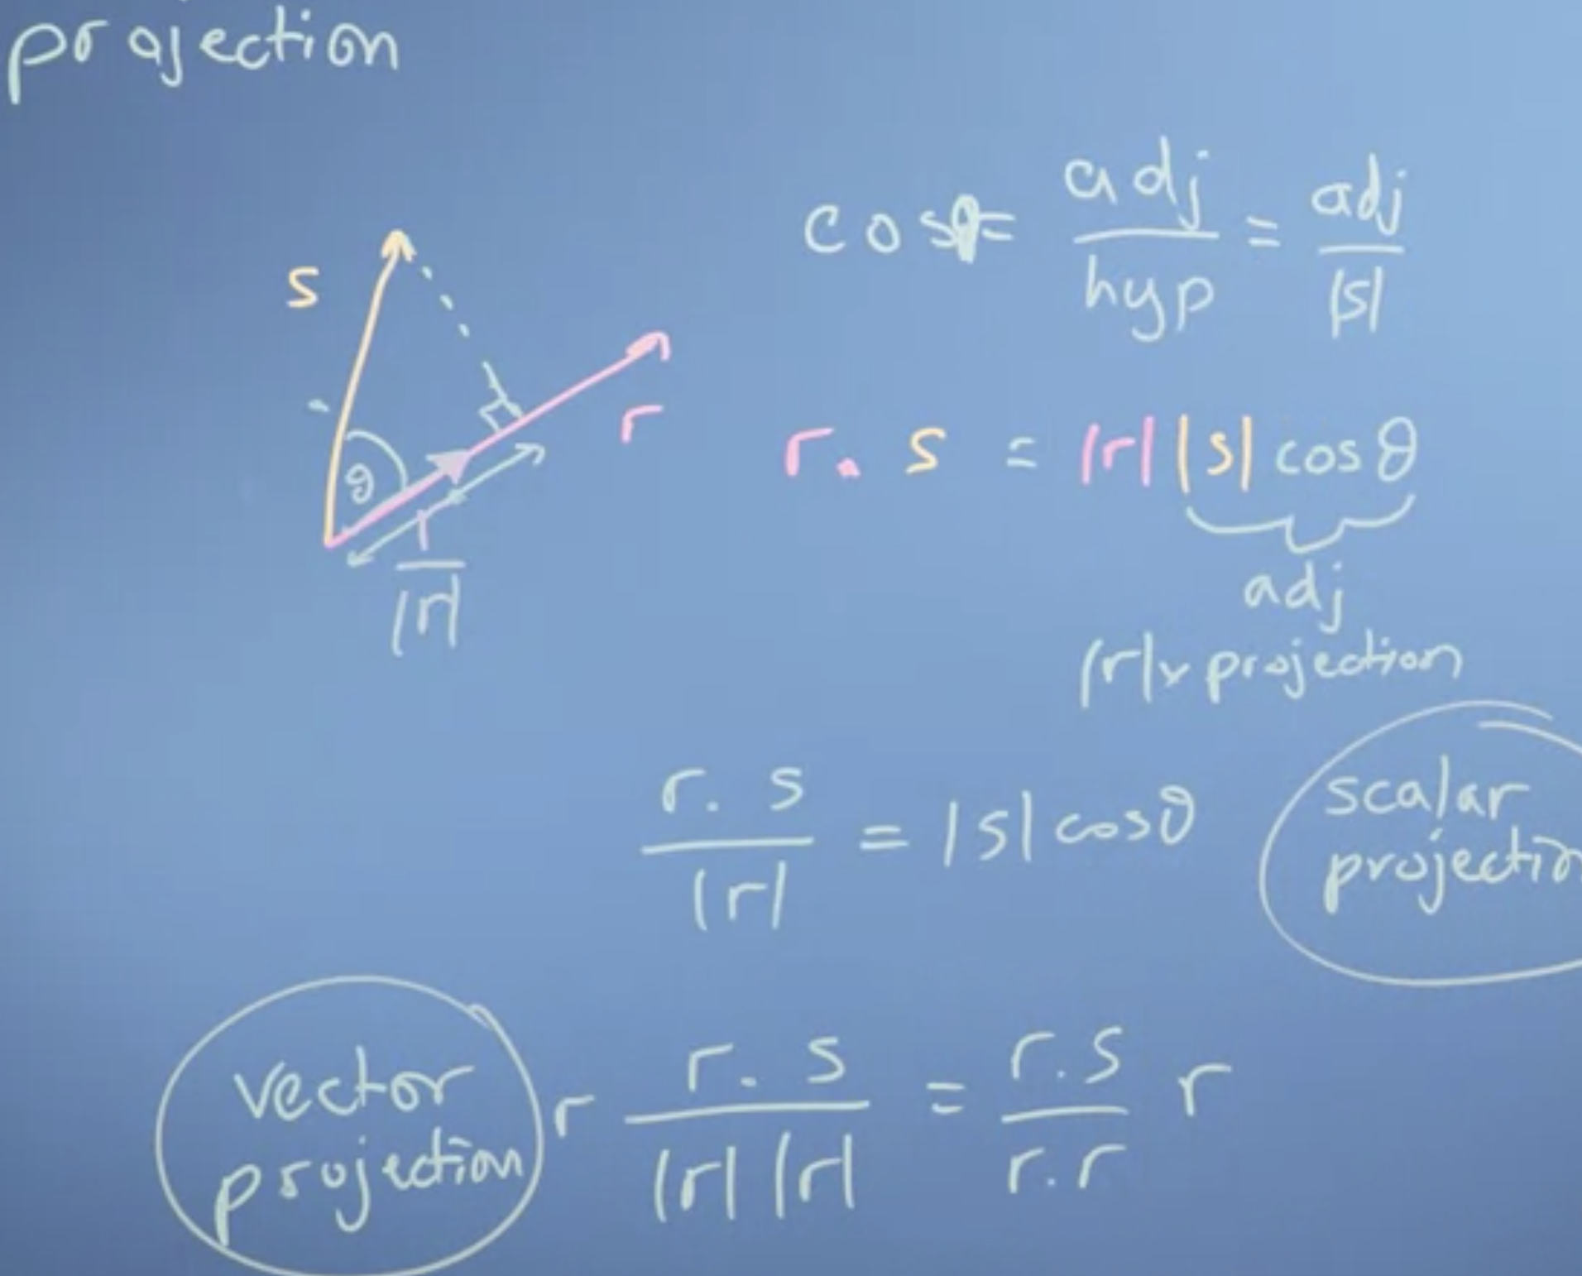

**Cosine**. is the horizontal coordinate of the arc endpoint. A convenient mnemonic for remembering the definition of the sine, **cosine**, and tangent is SOHCAHTOA (sine equals opposite over **hypotenuse**, **cosine** equals **adjacent** over **hypotenuse**, tangent equals opposite over **adjacent**).

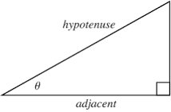

Vector projection:

Scalar projection = r.s / |r|

Component of s in the direction of r: vector project. In this case, you take the normalized (unit vector) r / |r| times the scalar projection of s onto r.

**Changing the reference frame:**

New basis vector have to orthogonal to each other.

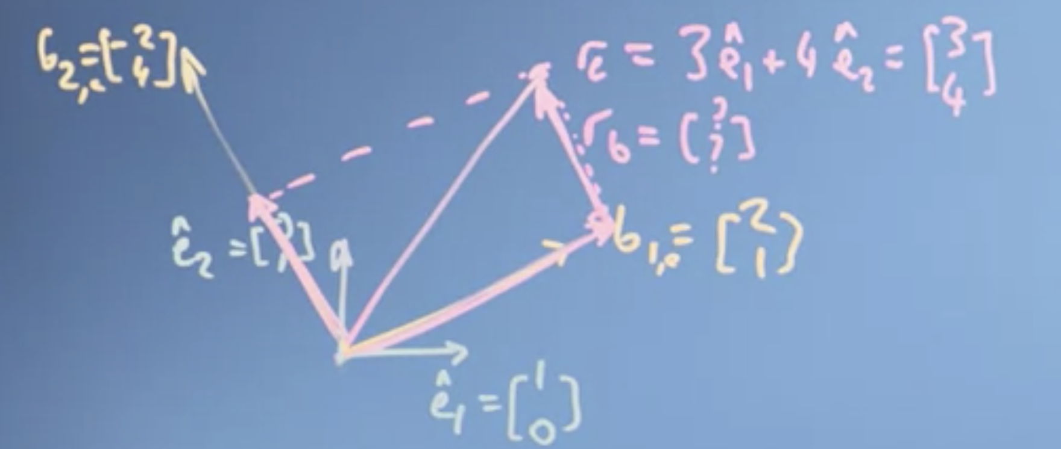

Using dot-products in this special case where the new basis vectors are orthogonal to each other, is computation a lot faster and easier, it's just less generic. But if you can arrange the new axis to be orthogonal, you should, because it makes the calculations much faster and easier to do. So, you can see that if I project r down onto b1, so I look down from here, and project down at 90 degrees, I get a length here for scalar product, and that's scalar projection is the shadow of r to b1. A number of the scalar projection describes how much of this factor I need. The vector projection is going to actually give me a vector in the direction of b1, of length equal to that projection. Now, if I take the vector projection of r onto b2 going this way, I'm going to get a vector in the direction of b2 of length equal to that projection. If I do a vector sum of that vector projection, plus this guy's vector projection, I'll just get r

So in the basis of b1 and b2, rb is going to be two a half. Very nice. Two a half. So actually in the basis b it's going to be two a half there. So rb is 2 times b1 plus a half times b2.

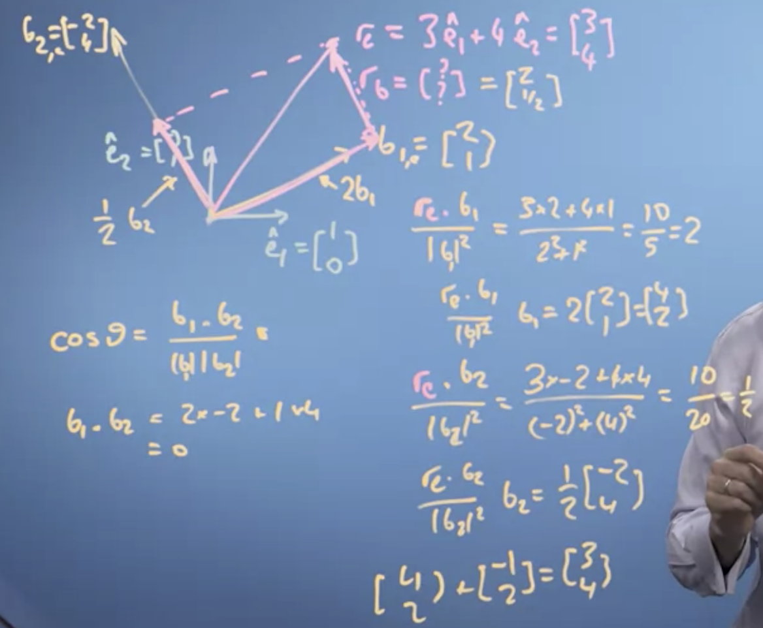

We've seen that a vector describing our data, isn't tied to the axes that we originally used to describe it at all. We can re-describe it using some other axis, some other basis vectors. So the basis vectors were use to describe the space of data, and choosing them carefully to help us solve a problem will be a very important thing in any algebra, and in general. What we've seen is we can move the numbers in the vector, we use to describe a data item from one basis to another. We can do that change just by taking the dots or projection product, in the case where the new basis vectors are orthogonal to each other.

we've seen how we don't just have to have basis vectors that are our normal one hour and 01, the so-called natural basis. We can have different basis vectors that we define how we move about space. In this video, we're going to define what we mean by a basis, by a vector space, and by the term linear independence, which is going to let us understand how many dimensions our vector space possesses.

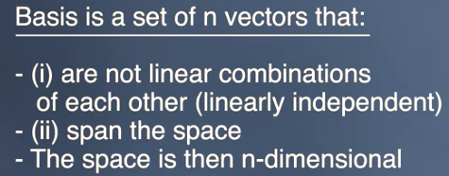

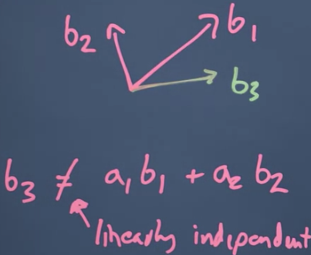

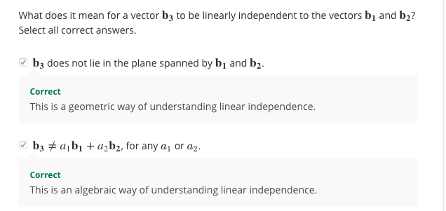

Now, notice what my basis vectors b don't have to be. They don't have to be unit vectors by which I mean vectors of length one and they don't have to be orthogonal, that is at 90 degrees to each other. But everything is going to be much easier if they are. So if at all possible, you want to use orthonormal basis factor sets, 90 degrees of unit length.

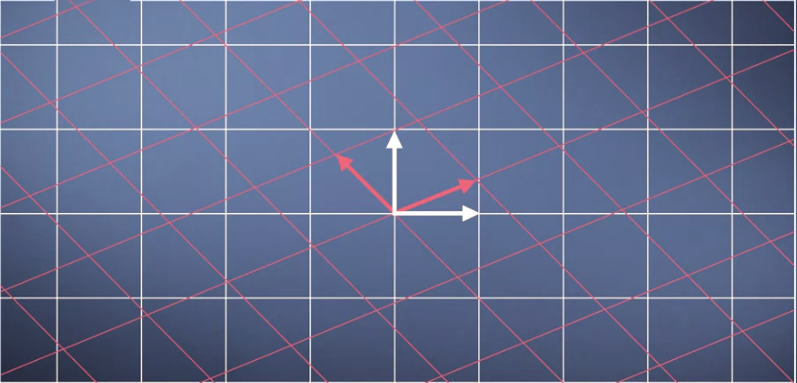

Now let's think about what happens when we map from one basis to another. The number line of the axis of the original grid then projects down onto the new grid and potentially has different values on that grid but the projection keeps the grid being **evenly spaced**. Therefore, any mapping we do from one set of basis vectors, from one coordinate system to another, keeps the vector space being a regularly spaced grid. Well, our original vector rules of vector addition and multiplication by a scalar still work. It doesn't [inaudible] fold space which is what the linear bit in linear algebra means. Things might be stretched or rotated or inverted, but everything remains evenly spaced and linear combinations still work.

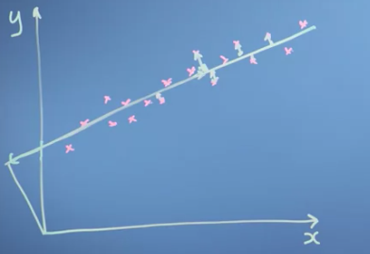

So when I'm doing data science it tells me how good my fit to my data is. The way I've defined these two directions along the line and away from the line, they are orthogonal to each other. So I can use the dot-product to do the projection to map the data from the x-y space unto the space of the line, along the line and away from the line, which is what we deal into in the last little segment. Now if we're thinking about a neural network in machine learning that recognizes faces say, maybe I'd want to make some transformation of all the pixels interface into a new basis that describes the nose shape, the skin hue, the distance between the eyes those sorts of things and discard the actual pixel data. So the goal of the learning process of the neural network is going to be to somehow derive a set of basis vectors that extract the most information-rich features of the faces.

Vector addition in this case. Think about it, you need to move from vector space to a 2 * in the direction of velocity vector.

S + 2* V = New position.

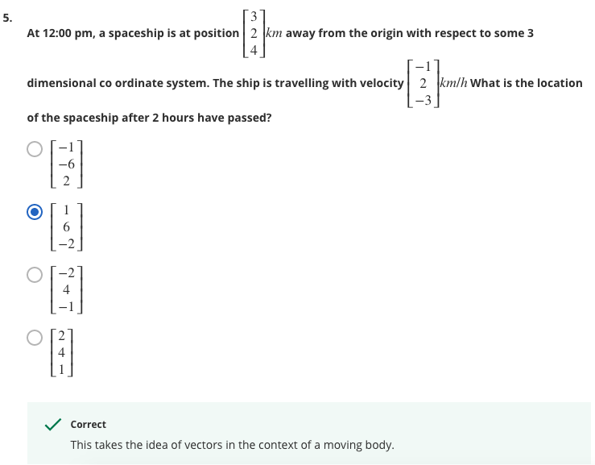

Matrices in Linear Algebra: Objects that operate on Vectors

Here we have just transformed using the matrix – Where does natural basis vectors land?

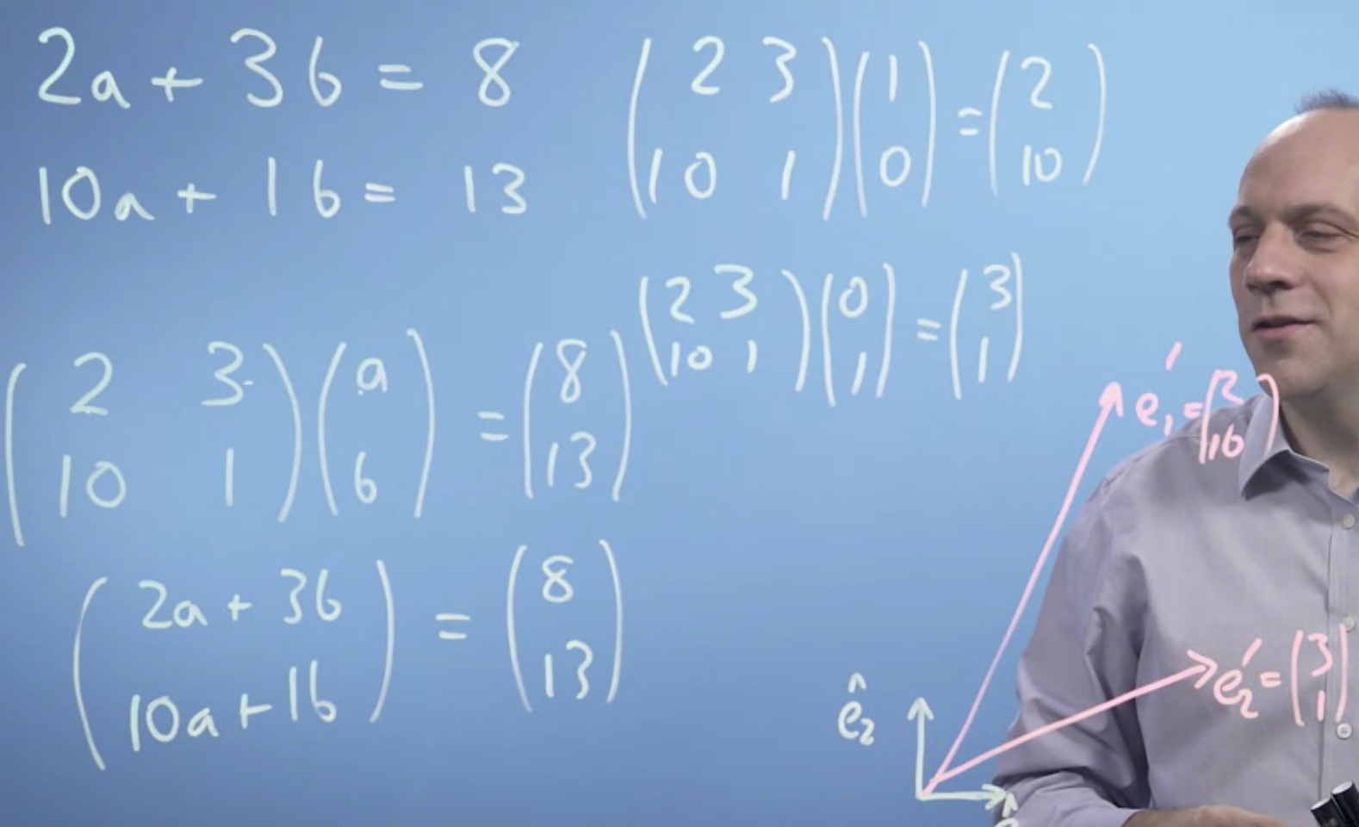

So what this matrix does, is it moves the basis vectors in some way, it transforms them, it changes the space.

Linear algebra is linear, because it just takes input values, our a and b, and multiplies them by constants. So everything is linear. And it's algebra, that is it's a notation describing mathematical objects and a system of manipulating those notations. So linear algebra is a mathematical system for manipulating vectors in the spaces described by vectors.

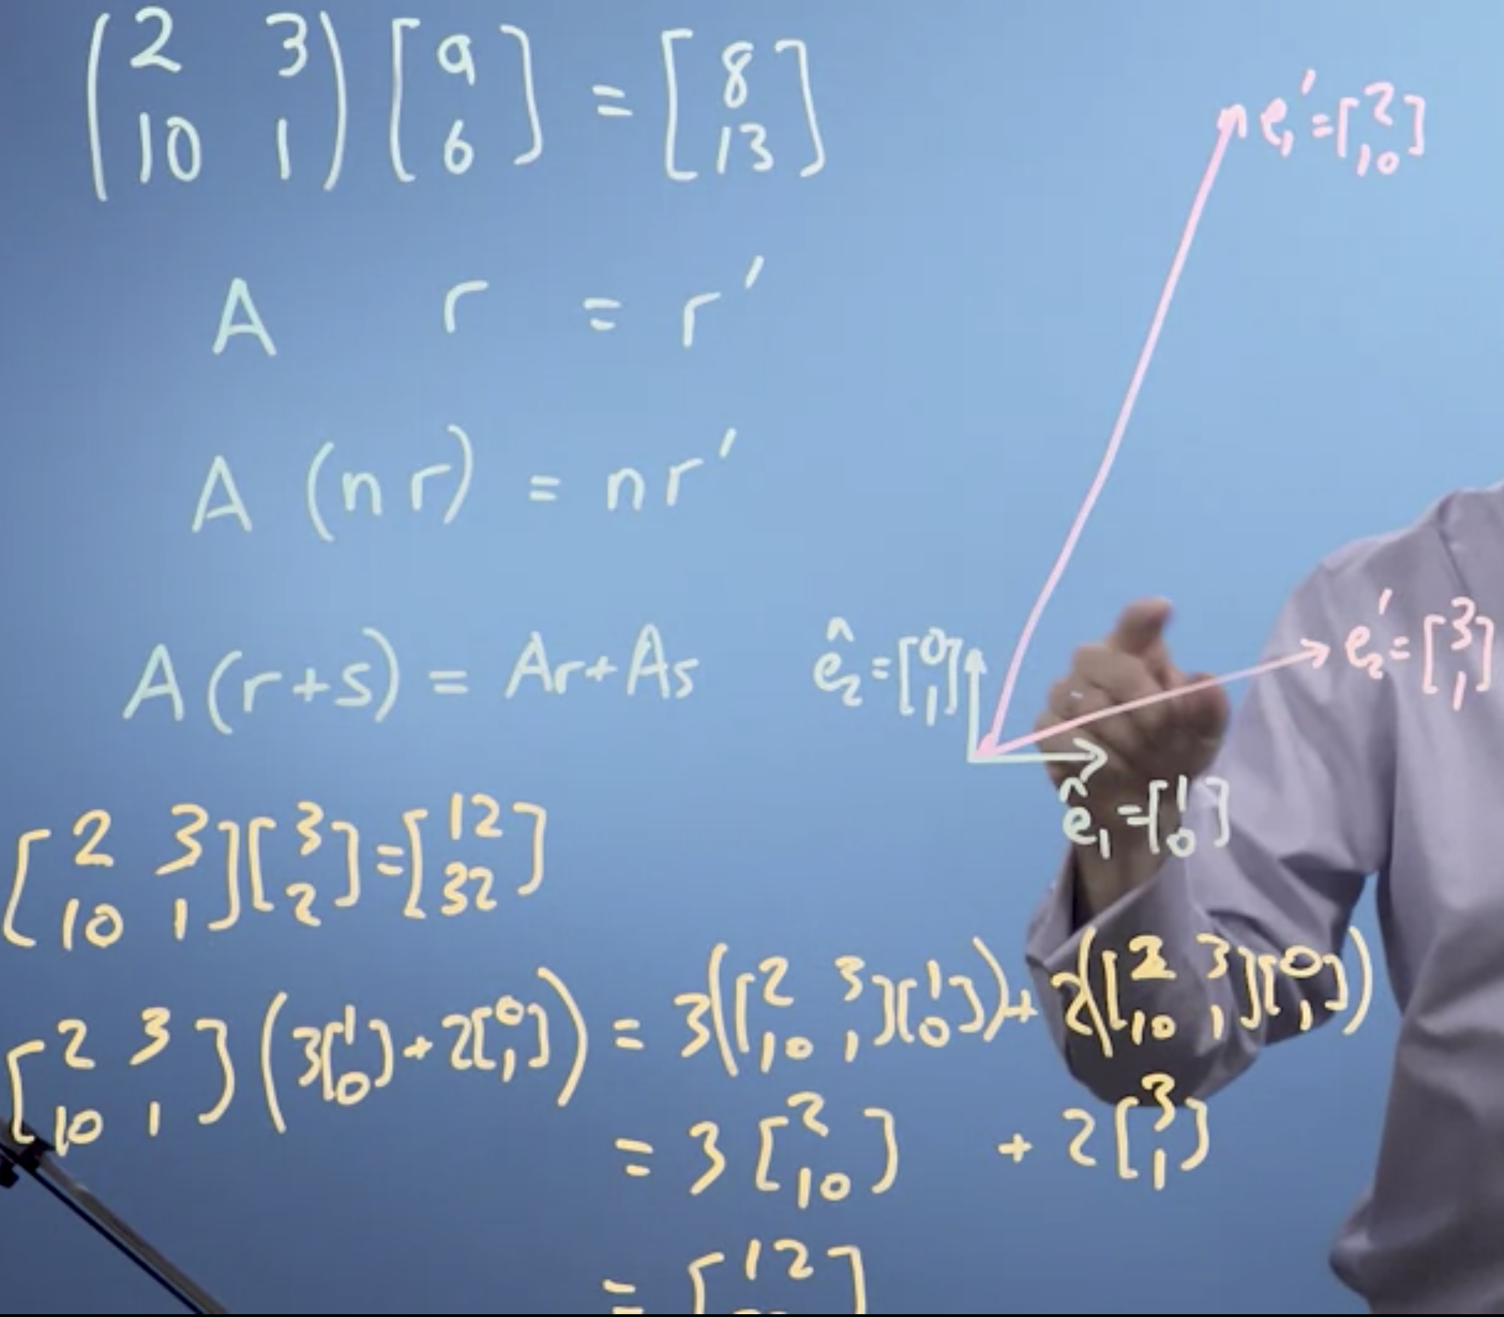

Identity Matrix

Multiple – Large

Fraction – Smaller

Negative – Change the orientation from right hand rule to a left-hand rule.

Inverse (Both are negatives)

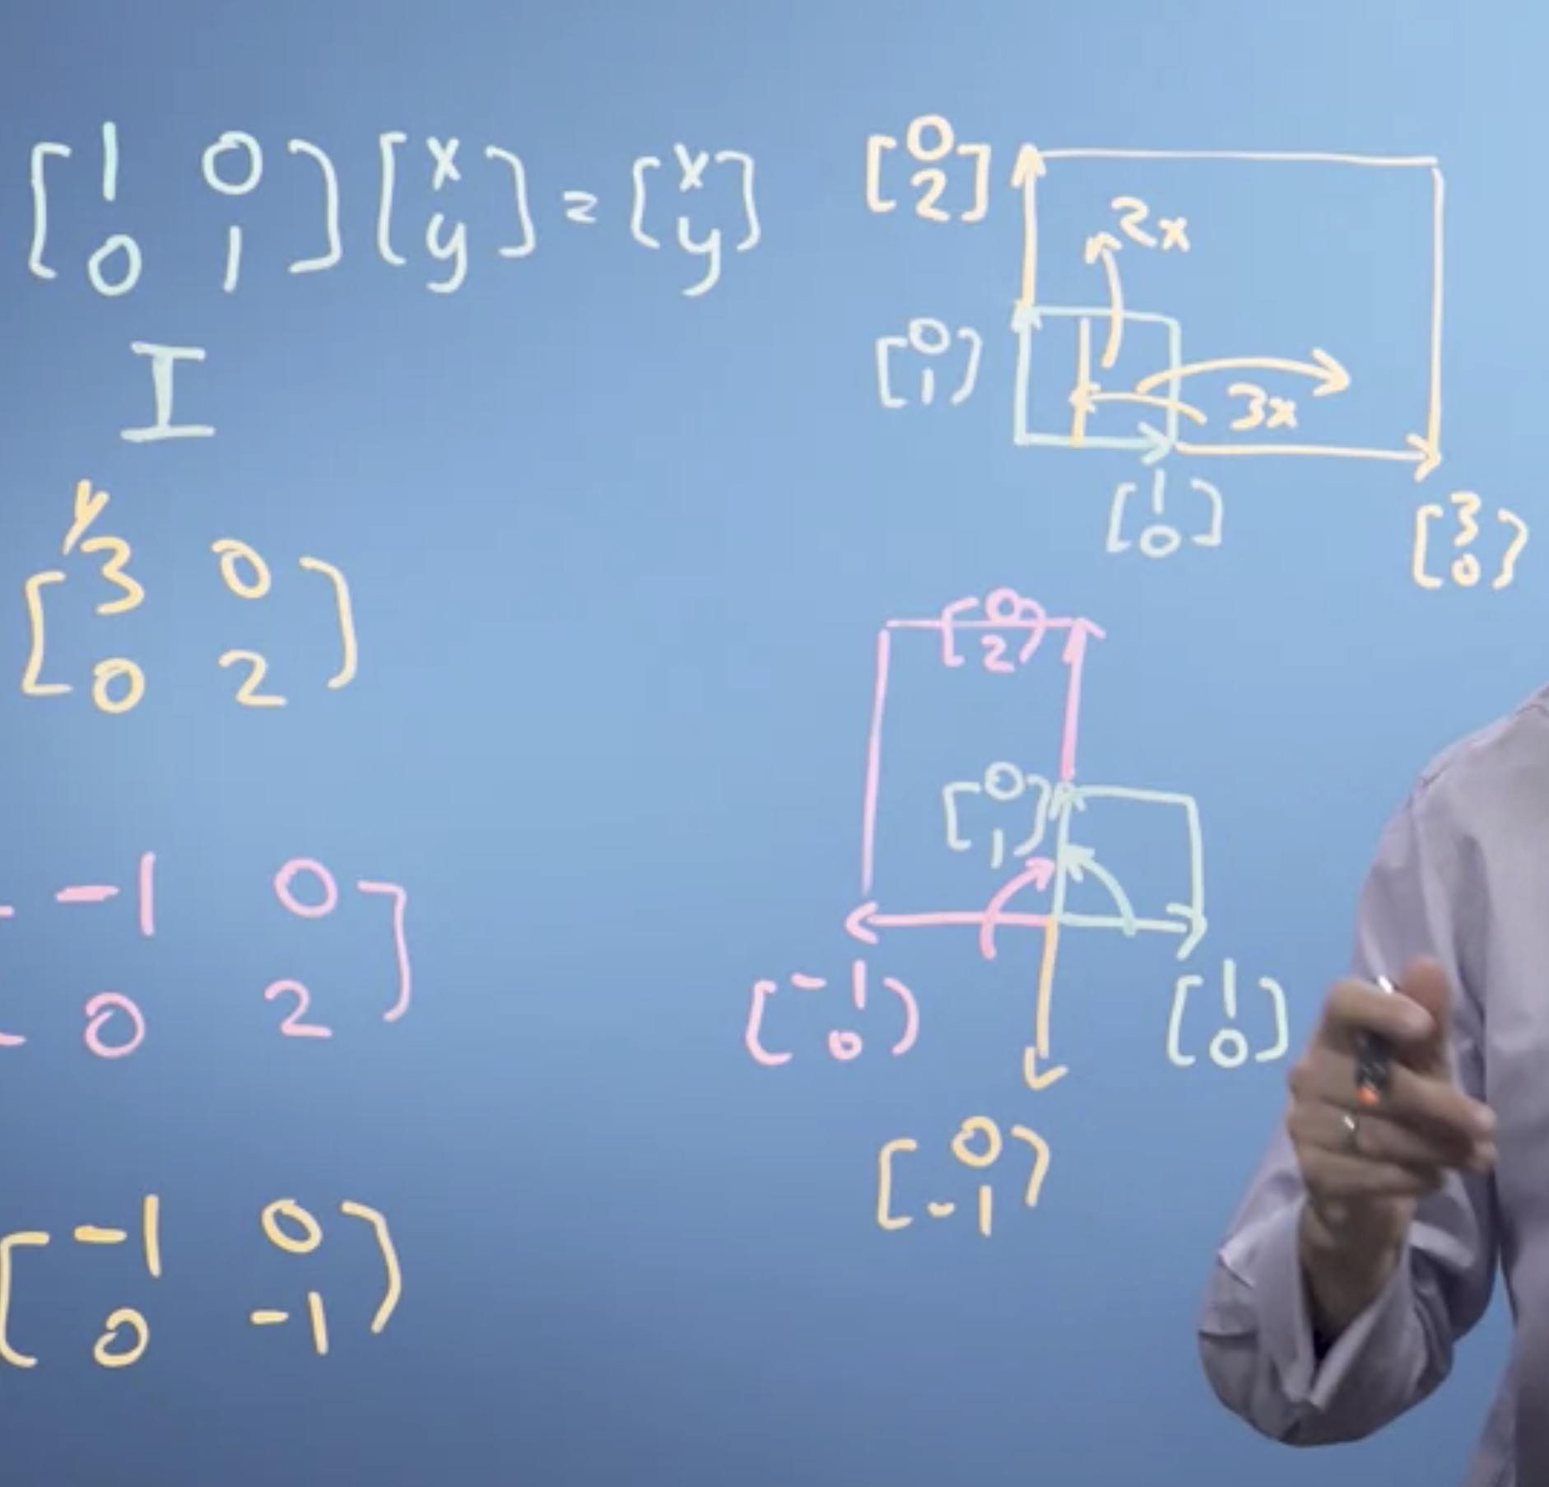

Mirrors:

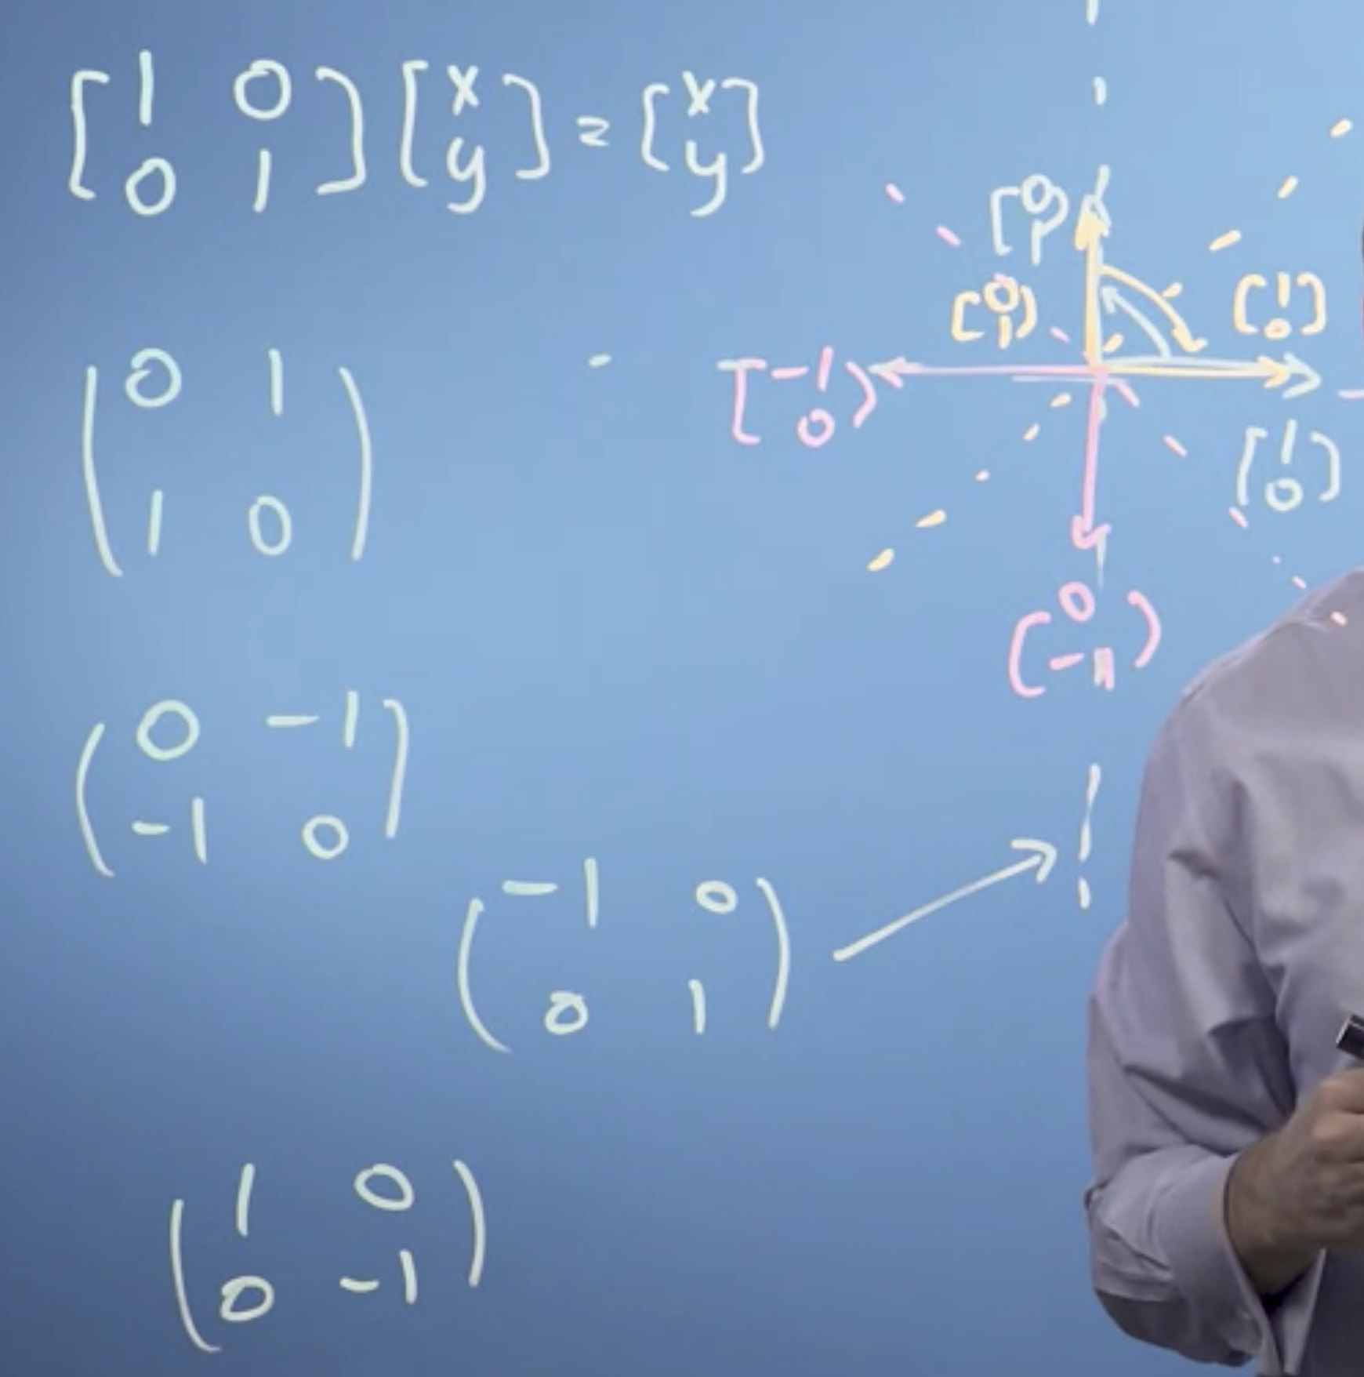

Shear.

Rotation.

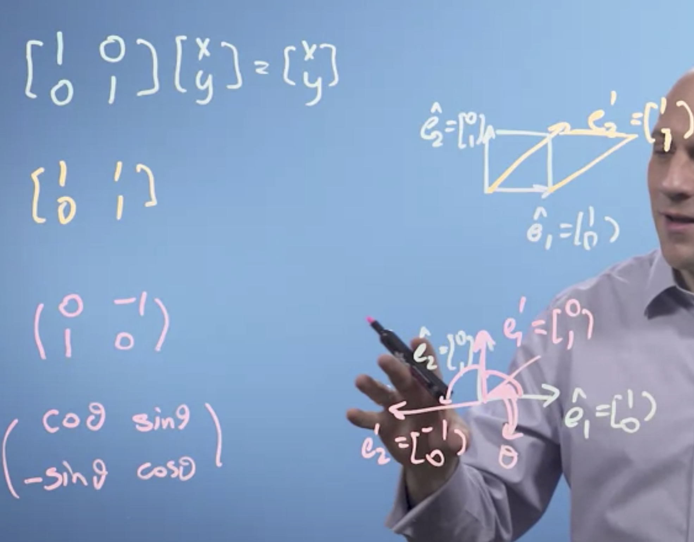

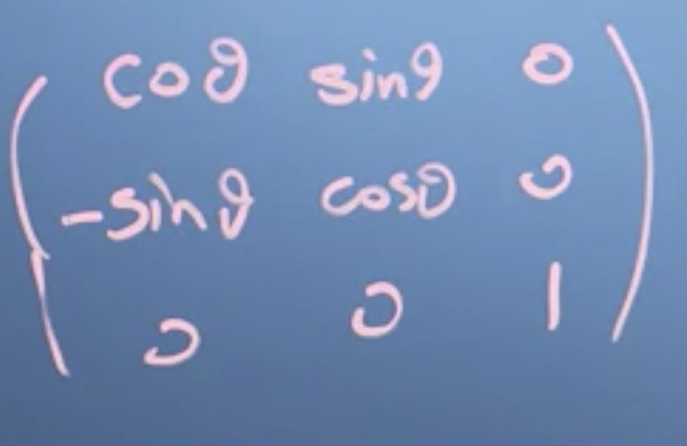

Matrix multiplication is not commutative but associative.

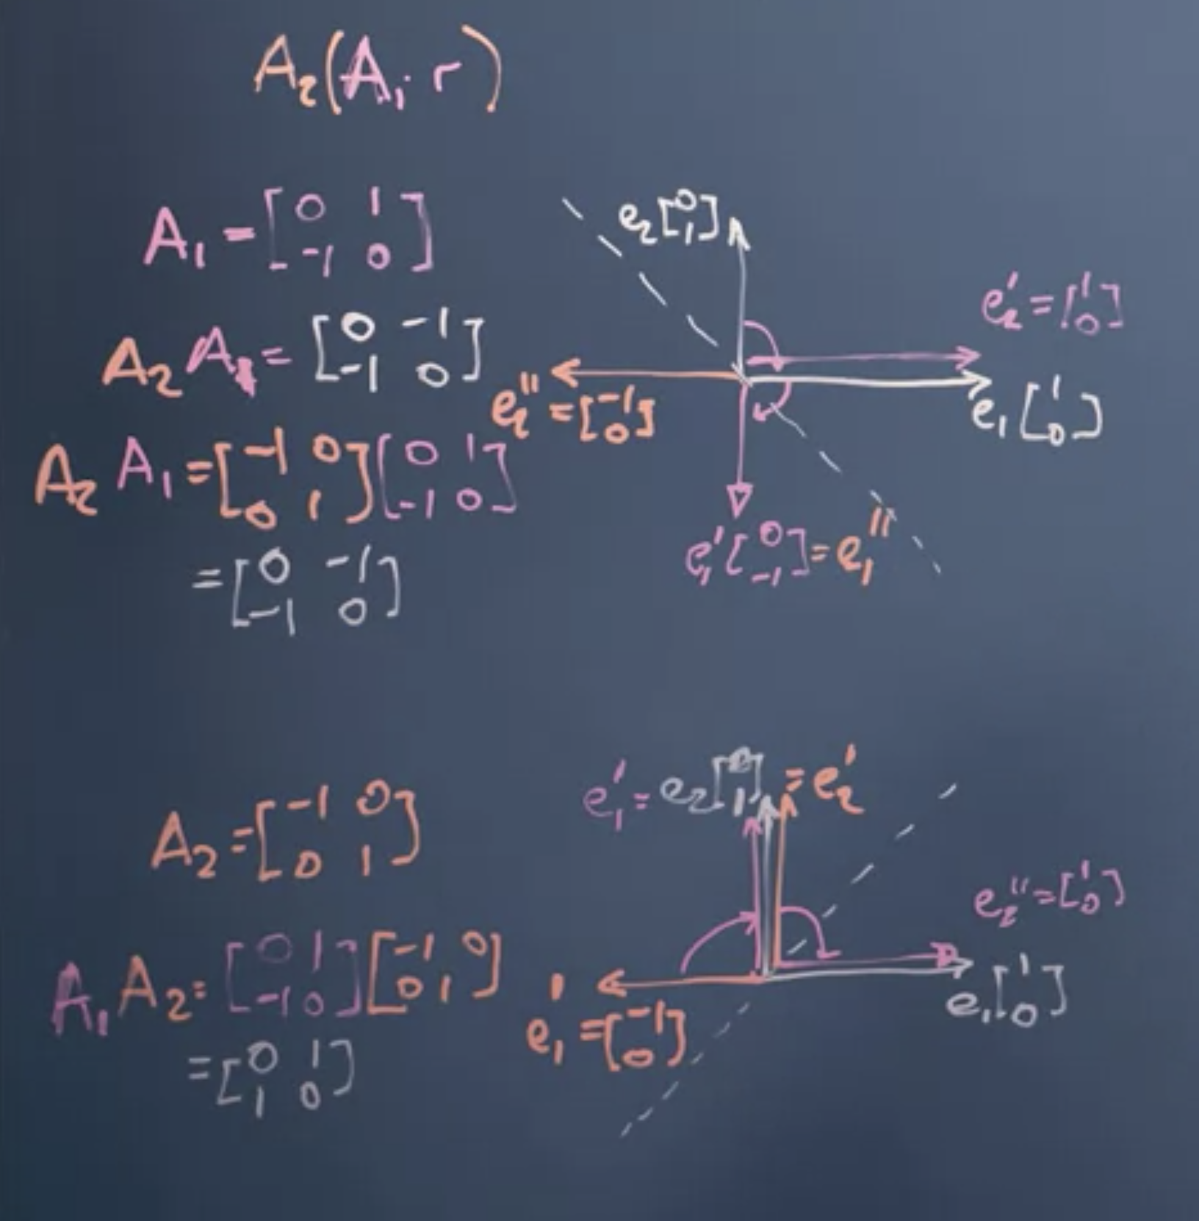

Transforming Images:



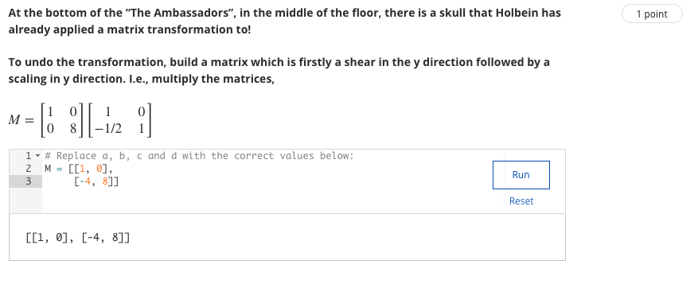

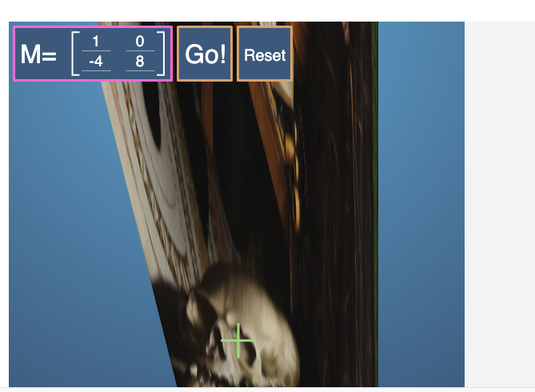

Gaussian Elimination: Solving the apples and bananas problem

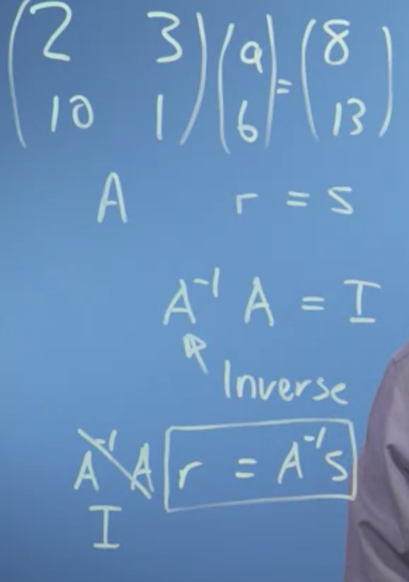

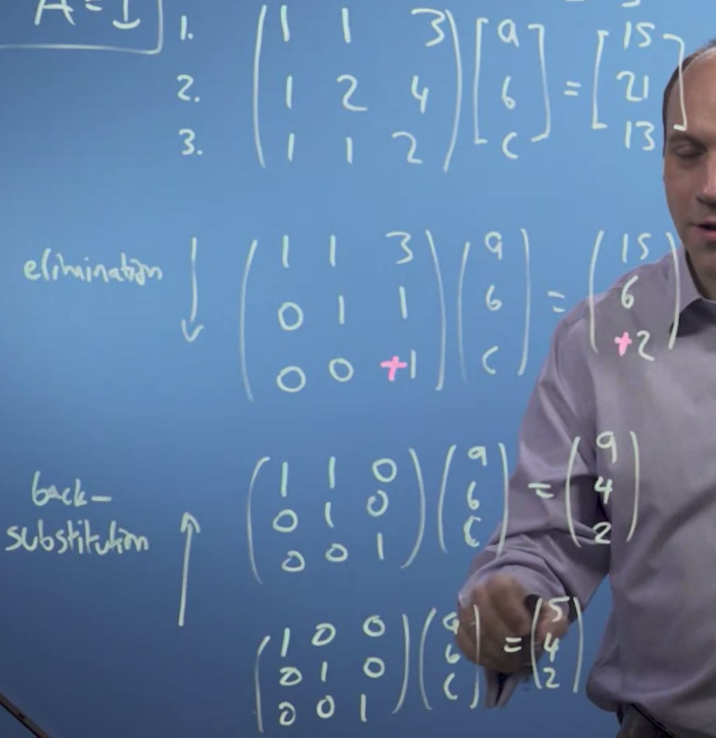

Solving the system of linear equations without taking the inverse but using the process of elimination.

Now, the thing to notice about a system of equations like this is that I can, if I take this row off of another row, I haven't changed anything, right? So, I know that an apple, a banana, and three carrots cost 15. So if I take an apple, a banana, and three carrots, and 15 off of the next row, I haven't changed anything really about that row, and the same for the third row. So, I can make this problem simpler by going and doing that, that sort of a process of elimination.

Let's change pens. And I've got a solution now for c, that c is equal to two, so that's interesting. Now, I've got what's called a triangular matrix, that is, everything below the body diagonal is zero. And that's a very interesting sort of matrix. I've reduced it to what's called Echelon form. All the numbers below the leading diagonal is zero. Now, I can do what's called back substitution.

Guassian Elimination is a faster method to find solve for the system of linear equations than taking the inverse.

